|  |
| --- |
| ERASMUS+ PROGRAMME  Project Number: 574010-EPP-1-2016-1-JO-EPPKA2-CBHE-JP |
| **FOODQA - Fostering Academia-Industry Collaboration in Food Safety and Quality** |
| Minutes of the Second Management Meeting |
| C:\Users\Dr\Downloads\FoodQA\th.jpg |
| HTWK, Leipzig-Germany |
| September 10-14, 2017 |

**Attendees:**

|  |  |
| --- | --- |
| **Jordan University of Science and Technology (JUST)** | |
| **Name** | **Profession** |
| Prof. Fahmi Abu Al Rub | Project manager of FOODQA Project |
| Dr. Khaled Al-Khatib | Director of Finance Unit |
| Eng. Qatada Damra | Administrative |
| **The University of Jordan (UJ)** | |
| Prof. Ahmed Al-Salaymeh | Professor at the School of Engineering and Technology/Contact Person |
| Eng. Leena Marashdeh | Administrative |
| **Mutah University (MU)** | |
| Prof. Omar Maaitah | Professor at the Faculty of Engineering/Contact Person |
| **Al Balqa’ Applied university (BAU** | |
| Prof. Tareq Azab | Professor, Contact Person |
| **MONOJO** | |
| Dr. Khalid Khraisat | Director of Services-MONOJO |
| Mr. Samir Nasrallah | Financial Manager |
| Mrs. Sahar Khaled | Project Manager |
| **Hochschule für Technik, Wirtschaft und Kultur Leipzig HTWK Leipzig (HTWK)** | |
| Prof. Klaus Hänßgen  Prof. Bernd Reichelt  Dr. Ryadh Qashi  Dr. Oleg Kritikov  Mr. Alex Dekin  Mrs. Maria Masold | Professor- Lecturer/Contact Person |
| **University of Teramo (UNITE)** | |
| Prof. Paola Pitila  Prof. Paparella Antonello | Professor/Contact Person  Professor |
| **Paulo & Beatriz – Consultores Associados, Lda (P& B)** | |
| Dr. Paulo Baptista | Managing Director/Contact Person |
| **Creative Thinking Development (Cre.Thi.Dev)** | |
| Ms. Sofia Papakonstantinou | Project Manager |
| Ms Lina Tsakalo | Researcher |
| **Agricultural University of Athens (AUA)** | |
| Prof. Theofilos Massouras | Contact Person |
| Mr. Nestor Papanikolaou | Researcher |
| **University of Split (UNSIT)** | |
| Prof. Josipa Giyanowic | Contact Person |
| Prof. Ante Prkic | Professor |
| **Jerash University (JU)** | |
| Dr. Ebrahim El-Tahat | Contact Person |
| Dr. Mysa Ata | Assistant Professor |
| **External Evaluator** | |
| Prof. Amr Amin | |

**Sunday, Sept. 10, 2017**

Prof. Abu Al-Rub and JUST team met with HTWK team to arrange for the meetings activities and make any changes to the agenda. They met with Mr. Marten Kraetke from le-tex publishing services, one of the leading companies in Germany in the e-materials publications, and agreed that Mr. Kraetke give workshop on September 11, 2017, to all FoodQA participants.

**Monday, Sept. 11, 2017**

**eBook production Workshop: Marten Kraetke; Lead Content Engineer, le-tex publishing services**

Mr. Martin Kraetke started his workshop by introducing le-tex publishing services. le-tex is specialized in Content Engineering – the highly varied range of tasks involved in producing publications. le-tex handles whole projects as well as individual process steps – for scientific products, schoolbooks, loose-leaf publications, extensive math typesetting, and printed and digital applications – with consistently high quality, excellent advice, and the necessary flexibility.

The most important conclusions of the workshop are:

* Books can be categorized according to their pagination:
* [PDF](https://www.le-tex.de/en/pdf.html)-based e-books correspond exactly to print products in terms of their pagination,
* Reflowable e-books adjust to the page makeup of the screen size and the font size selected and are therefore also suitable for viewing on smaller display devices.
* Reflowable e-books are best generated from structured data.
* Reflowable e-books can be converted easily to audio
* The most common data formats are [EPUB](https://www.le-tex.de/en/epub.html) (readable e.g. with Apple iBooks, Adobe Digital Editions, or on numerous other dedicated readers) and Mobipocket (Amazon Kindle). To be equipped to handle future updates of e-book data formats.
* Content should not be saved exclusively in one of the current e-book formats but also in an XML format that is fully compatible with the features and characteristics of the content. This enables questions and answers to be marked up in teaching materials, for instance, and the right answer to be indicated as such in multiple choice questions. This approach makes it possible in future to generate every e-book format that supports user interaction, which would not be possible if the data was configured exclusively on EPUB 2.
* The selection criteria for a typesetting system, apart from criteria dictated by customer requirements or special features specific to the project, are shown in the following table:

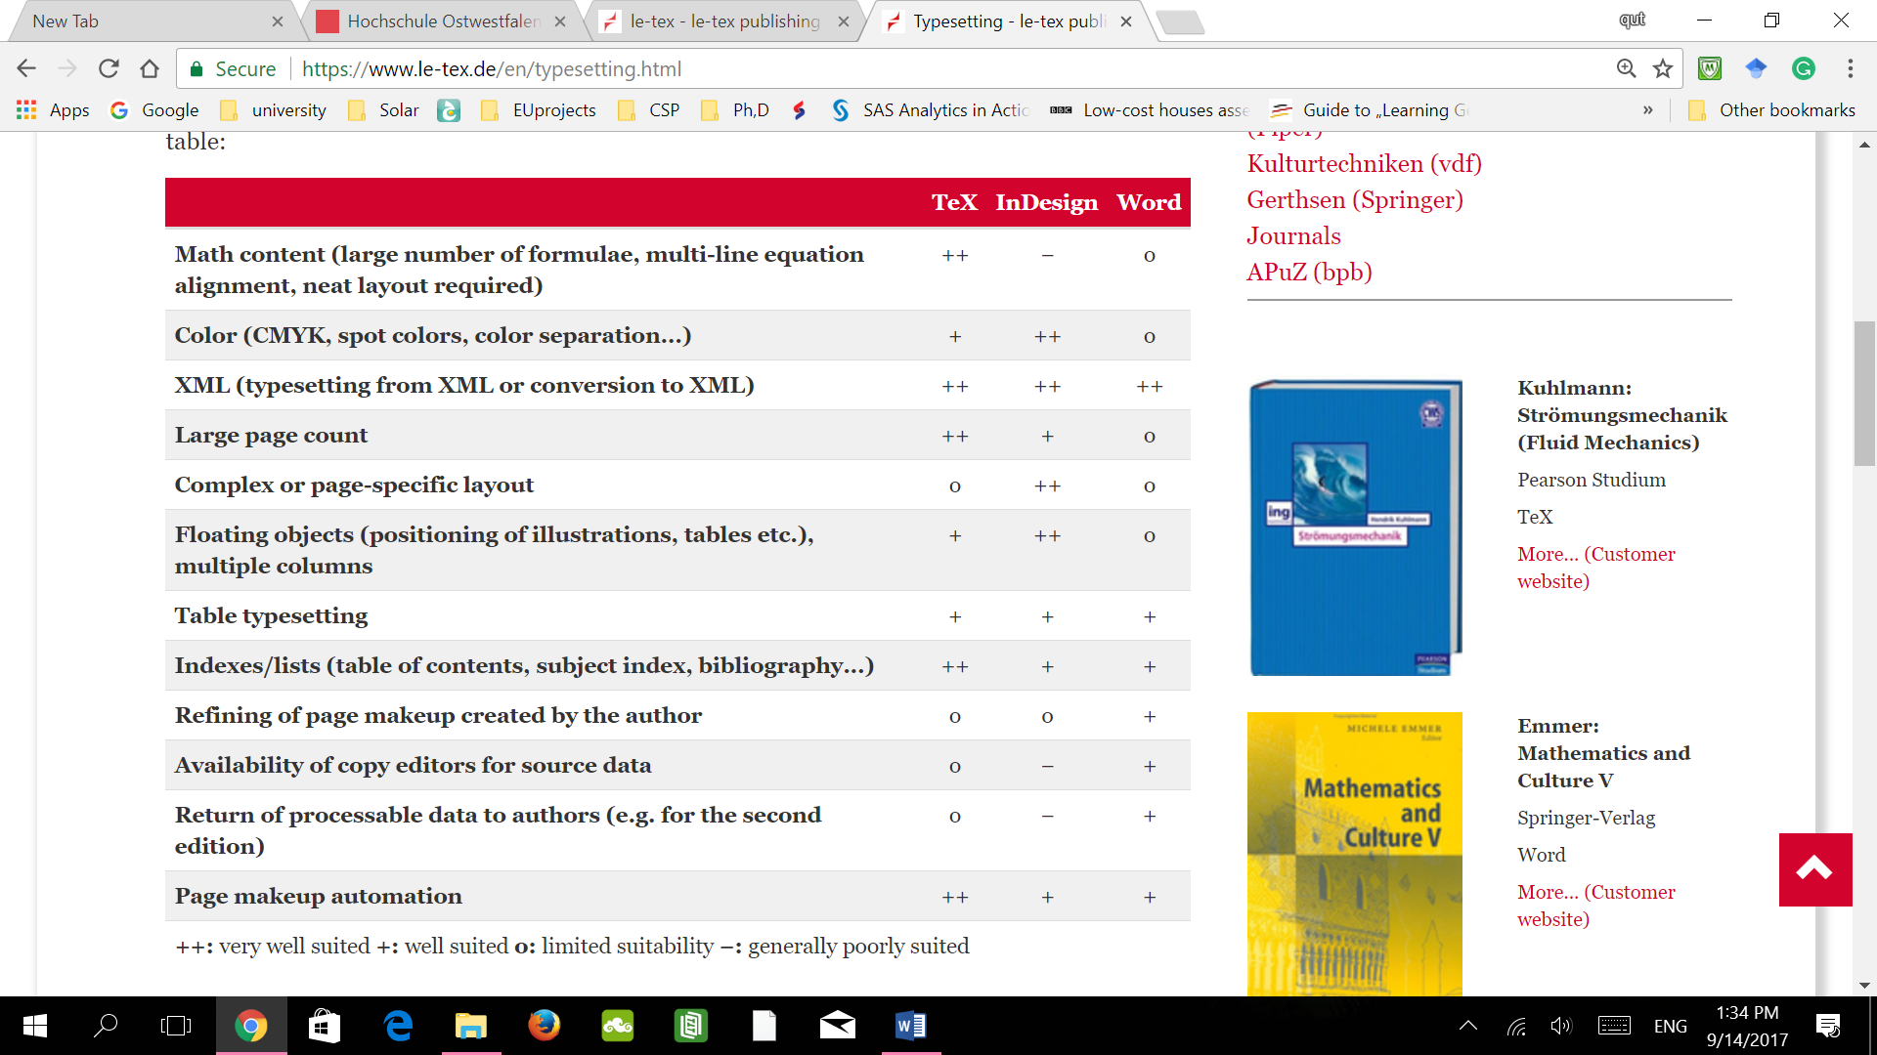

**Digital Right Management:**

As many of the participants was interested in this topics Mr. Kraetke briefed them about this topic, especially about the software they can use or the companies they can hire, also some ways to make your document traceable like watermarks. However, he also stated that there will always be a way to hack it, so it might not worth the stress.

The second day meeting was adjourned at 18:00.

**Tuesday, Sept. 13, 2017**

**Welcoming Remarks& Progress of “FoodQA Project”:** At the beginning of the meeting, Representative of Prof. Klaus welcomed the participants.

**FoodQA Project Overview**

* Prof. Abu Al Rub – Project manager-JUST, outlined the project Progress of all FoodQA WPs.

**WP1: Development of training materials: Paulo – from P&B**

**e-books:**

The Proposed structure and “model” eBook was introduced by Paulo. It was agreed to make some modification on the model of the e-books. The changes introduced were the following:

• The proposed type of the final version for publishing is PDF, and the alpha and beta versions is in word.

• Index was moved from the end to the beginning, after the first page

• Introduction was included in the Index

• In the first page, "Authors" was changed to by "Editor".

• The names of authors who contributed in the preparation will be listed on the 1st page of each chapter.

The partners agreed that the English version of the eBooks must be camera ready by the end of October. To meet this deadline, the partners agreed on the followings:

• All the partners should send an email to the coordinator defining what chapters are ready and what are missing from the eBooks they are working on by 18th of Sep.

• All the partners who need materials and references will send an email by 18th of Sep. and CC the project coordinator, Abu Al Rub.

• All the ready chapters should be send to the work package leaders by the end of September according to the revised model by 18th of Sep.

• The contacted partners regarding the references and the related material should reply and send all needed information by the end of Sep.

• The remaining chapters and sections from Split, AGU, UniTE, CRE.THI.DEV, P&B should be finalized by 15 Oct.

• The chapters on the cleaning and disinfection should be ready by mid of October

• The chapter on the HACCP system should be postponed to the end of this year to include the new edition of the system and its guidelines.

**Other issue related to the e-books production:** The Partners agreed to assign an ISBN or ESBN number for the eBooks

**Peer-review of eBooks:**

Based on the partners experience this can be very helpful. The content of the eBooks should be peer reviewed by an expert who was not part of the preparation process.

• The final edition for publishing shall be edited by the project coordinator

• If the peer reviewer is working within the partner organization then he (she) will be paid from the staff cost. If not then she (he) will be paid through subcontracts.

**Video production of videos and posters**

Paulo suggested a method of producing the videos. According to this method, first a video script shall be written that contains the message to be communicated or conveyed through the video, combined with images and pieces of video that are original and taken by the partners. All the scripts with the images and videos should be sent to HTWK Leipzig for the production by the end of September. The European partners should be responsible for the text and the scientific material and the Jordanian partners will be responsible for the media.

The same methodology should be followed for posters and the ready scripts should be sent to Balqa Applied University by the end of September and the poster should be camera ready by 15 October.

The European partners will send information about the media needed to be collected by the Jordanian partners by 20th of September.

**WP2: Development of training courses: Paola, UniTE**

The partners have agreed to keep the guideline of this work package as the proposed.

Regarding the training of JO staff in EU, the following table summarizes the dates and places of the training:

|  |  |  |  |  |
| --- | --- | --- | --- | --- |
| Working Module/ Course | Contact hours | Task Leader | Training place | Date |
| Food and safety hazards | 16 | UNiTE | Teramo | January |
| Food safety management system | 32 | P&B | Portugal | February |
| Personal hygiene | 4 | AUA | SPLIT | March |
| Design and controlling of food premises | 16 | SPLIT | SPLIT | March |
| Cleaning and disinfection | 16 | SPLIT/UNiTE | Teramo | January |
| Pest control | 12 | BAU/SPLIT | SPLIT | March |
| Quality management systems | 32 | AUA | Athens | April |
| Quality management tools | 32 | CREATIVE | Athens | April |

* The work package leader will send the syllabus and the learning objectives by the end of September to the topic leaders and the training organizer.
* The topic leaders and training organizer will define the selection criteria and the minimum requirement of the trainees and send it to the project coordinator by the end of October.

**e-Learning Courses**

* The partners agreed to make minor modifications to the titles of the courses.
* A core group was formed to decide and manage on the issues regarding conducting the eLearning Courses, the group includes; P&B, UNiTE, SPLIT, UJ, and JUST.

**WP3: Training of academia and industry: (Qatada-JUST)**

* Qatada presented the results of the surveys on Food Industries Training Needs.
* The survey aimed at identifying the needs of the JO food companies for the training: types, and modes of training.
* 41 companies completed the surveys
* A cording the completed surveys, the followings can be concluded:
* The result shows that 56% of the surveyed companies apply one or more quality system, about 20% of the companies apply more than one quality system. The most quality system applied is ISO9001 then ISO 22000 then HACCP.
* about 2/3 of the surveyed companies think that perception of the level of qualification of the qualified technical staff are on average or below.
* The survey shows that there is higher need of training of qualified staff rather than the general worker, because general workers can be trained by their team leaders and supervisors, so, focusing on leaders and higher staff levels training would be more efficient.
* The accumulated result shows that although Intra-company training is the most preferred type, E-learning have high acceptance among respondents.
* Qatada Referred to the survey report for further details.

**Preparation of the seminars:** Dr. Khaled and Sahar-MONOJO) presented the action plan for the seminars to be conducted in Jordan.

FOODQA Partners agreed that GMP should be added to the training courses as it is a perquisite for ISO 22000. They also agreed on partners that will be responsible of preparing the 5 one-day seminars as the following:

1. JFDA, MONOJO, P&B will be responsible for general food laws (Principles, food hygiene, traceability)

2. JFDA, MONOJO, UniTE and MU will be responsible for labelling and nutrition (Food labelling, health and nutrition claims, Nutrition labelling, food supplements, addition of vitamins and minerals, dietetic foods, food for infants and young children, food for weight reduction, food for special medical purposes, food for sport people, food for diabetics).

3. JUST, MONOJO and AUA will be responsible for chemical safety (Additives, flavoring, contaminants, Antibiotic residues, pesticide residues, food contact materials, hormones in meat, fraudulent practices).

4. MONOJO, BAU, AUA will be responsible for biology safety (Food hygiene, BSE/Scrape, Animal by-products, food-borne diseases, microbiological criteria, irradiation).

5. MONOJO, UJ and one partner from EU will be responsible for genetically modified food and feed (Labelling and traceability).

The In-room training courses will be designed to contain one quality or food safety standard, the partners involved in quality management systems (ISO 9001:2015) training course are MONOJO and JFDA, for the food safety management systems (ISO 22000:2005) training course are MonoJO and JUST

For the following training course; the partners to be responsible for preparing them will be agreed on latter:

1. BRC Global standard food (Issue 5)

2. IFS (International food standard 5)

3. Global gap.

According to this plan, the seminars are suggested to be during the Academia-Industry Council meetings. The first seminar should be held in November and the announcement will be three weeks earlier and the outline of the seminar should be decided by the end of September. The coordinator will make a doodle to set the exact date by the next week.

**WP4: Pilot of implementation of food safety and quality management systems**

Abu Al-Rub presented WP4. The main objective for this work package is to provide in-job training to the staff of the FoodQA centres to let them acquire the competences and experience in the implementation of food safety management system, BRC Global standard, IFS and global GAP.

* 8 companies will be used a pilot.
* Each one of the standards will be implemented at least in one company in in order to provide in-job training in all the standards.
* The implementation process is expected to have in average 1 year in each company
* Specific partners will conduct one independent audit in each of the companies/organizations where one of the managing systems is being implemented, to make a complete assessment of the work carried out by experts involved in the implementation, through the verification of the conformity of the system implemented.

**WP5: Dissemination**

* Riyadh from HTWK presented the Dissemination plan of the FoodQA project.
* He emphasized on using the templates of FoodQA projects in all project’s activities.
* It was agreed that UJ to prepare and publish the second issue of the FoodQA Newsletter.
* Abu Al-Rub presented the FoodQA website and discussed its features.
* Mrs. Saher from MONOJO presented the results of the first meeting of the Academia Industry Council, which was held in Amman in May 2017.
* Prof. Al-Salaymeh from UJ presented the sustainability plan of the FoodQA project. The plan identifies some actions needed to sustain the project activities and outputs after the life-time of the project.

**WP 6: Quality (CRE.THI.DEV)**

Mrs. Lina Tsakalou from CRE.THI. DEV presented the Quality Plan WP. She started by introducing the WP and describing its importance to ensure achieving the project’s objectives and deliverables. Then she discussed each task in the WP and she proposed a strategy or methodology to achieve these tasks. The approved quality plan for the project was discussed and elaborated. will be developed by the committee; this plan will be the roadmap for the evaluation of the quality of the project.

**WP7: Management**

* Abu Al-Rub presented the activities of the Management WP.
* He updated the consortium on the six-month reports prepared by each WP leader.
* **He urged all partners to follow the EACEA financial guidelines when using their budget.**
* The fourth management meeting will be in Porto-Portugal in Jan. 2018.

The third day meeting was adjourned at 18:00.

**Wednesday, Sept. 14, 2017**

Dr. Khlaed Al-Khatib and Dr. Tareq Azab visited the facilities of some publishing and media prodcution companies. They also visited the department of Media at HTWK.